UDC 625
IRSTI 85:665.775
REVIEW ARTICLE

THE USE OF NATURAL BITUMEN
AS A MODIFIER OF ASPHALT CONCRETE MIXTURES

M.B. Zhumamuratov^{1*}, N.E. Bekturganova¹, D.E. Yessentay¹, J. Valentin²,
I.S. Bondar¹

¹KazADI named after L.B. Goncharov, 050061, Almaty, Kazakhstan
²Czech Technical University in Prague, Prague, Czech Republic

Abstract. The article presents a structured narrative literature review of modern research on the use of natural bitumen as a modifier of asphalt mixtures. The main varieties of natural bitumen used in road construction are considered, including Gilsonite, Trinidad Lake Asphalt (TLA), rock asphalt and petrobituminous rocks (oil sands). The analysis of the physico-chemical mechanisms of interaction of natural bitumen with petroleum bitumen, including the influence of asphaltenes, resinous compounds and mineral components on the rheological characteristics of binders, is carried out. Special attention is paid to the influence of natural bitumen on the resistance of asphalt concrete mixtures to rutting, water resistance, aging resistance, fatigue life, modulus of elasticity and low-temperature crack resistance. The reviewed laboratory studies generally indicate that selected natural bitumen modifiers can increase binder stiffness and high-temperature stability. Depending on the modifier type, dosage and mixture system, some studies also report improvements in rutting resistance and moisture-related performance. However, higher modifier contents may reduce low-temperature flexibility, and these laboratory trends should not be interpreted as direct evidence of long-term field durability. Based on the reviewed international evidence and the regional context of Kazakhstan, the potential applicability of natural bitumen modifiers under severe operating conditions is discussed. However, further local experimental and field validation is required before large-scale implementation. Key scientific gaps and promising areas for further research have been identified, including optimizing dosages, adapting technologies to local climatic conditions, and using domestic bitumen resources.
Keywords: natural bitumen, gilsonite, Trinidad Lake Asphalt (TLA), rock asphalt, modified bitumen, asphalt concrete, rutting.

*Corresponding author
Manarbek Zhumamuratov, e-mail: zhumamuratovmanarbek@gmail.com

ӘОЖ 625
ҒТАМР 85:665.775
ШОЛУ МАҚАЛА

ТАБИҒИ БИТУМДЫ АСФАЛЬТБЕТОН ҚОСПАЛАРЫНЫҢ МОДИФИКАТОРЫ РЕТІНДЕ ҚОЛДАНУ

М.Б. Жумамуратов^{1*}, Н.Е. Бектурганова¹, Д.Е. Есентай¹, Я. Валентин²,
И.С. Бондарь¹

¹Л.Б. Гончаров атындағы Қазақ автомобиль-жол институты, 050061, Алматы, Қазақстан
²Прагадығы Чех техникалық университеті, Прага, Чех Республикасы

Аңдатпа. Осы мақалада табиғи битумды асфальтбетон қоспаларының модификаторы ретінде қолдану бойынша заманауи зерттеулерге құрылымдалған нарративтік әдеби шолу ұсынылған. Жол құрылысында қолданылатын табиғи битумның негізгі түрлері, соның ішінде Gilsonite, Trinidad Lake Asphalt (TLA), тас асфальт (rock asphalt) және табиғи текті мұнай-битумды жыныстар қарастырылған. Асфальтендердің, шайырлы қосылыстардың және минералдық компоненттердің байланыстырғыштардың реологиялық сипаттамаларына әсерін қоса алғанда, табиғи битум мен мұнай битумының өзара әрекеттесуінің физика-химиялық механизмдеріне талдау жүргізілген. Табиғи битумның асфальтбетон қоспаларының ізтүсуге төзімділігіне, суға төзімділігіне, қартаюға тұрақтылығына, шаршау беріктігіне, серпімділік модуліне және төмен температуралық жарықшаққа төзімділігіне әсеріне ерекше назар аударылған. Қарастырылған зертханалық зерттеулер, әдетте, таңдалған табиғи битум модификаторлары байланыстырғыштың қаттылығын және жоғары температура тұрақтылығын арттыра алатынын көрсетеді. Модификатордың түріне, мөлшеріне және қоспалар жүйесіне байланысты кейбір зерттеулер сонымен қатар ылғалға төзімділік пен өнімділіктің жақсарғанын хабарлайды. Дегенмен, модификатордың жоғары мазмұны төмен температураның икемділігін төмендетуі мүмкін және бұл зертханалық үрдістерді өрістің ұзақ мерзімді беріктігінің тікелей дәлелі ретінде түсіндіруге болмайды. Қарастырылған халықаралық зерттеулердің нәтижелері мен Қазақстанның өңірлік ерекшеліктерін ескере отырып, күрделі пайдалану жағдайларында табиғи битум модификаторларын қолдану мүмкіндігі талқыланды. Алайда оларды кең ауқымда енгізу алдында жергілікті жағдайларда қосымша зертханалық және далалық сынақтар жүргізу қажет. Негізгі ғылыми олқылықтар мен болашақ зерттеулердің перспективалы бағыттары айқындалды, соның ішінде мөлшерлемелерді оңтайландыру, технологияларды жергілікті климаттық жағдайларға бейімдеу және отандық битум ресурстарын пайдалану мәселелері қарастырылды.
Түйін сөздер: табиғи битум, гильсонит, Trinidad Lake Asphalt (TLA), тас асфальт, модификацияланған битум, асфальтбетон, ізтүзілушілік.

*Автор-корреспондент
Манарбек Жумамуратов, e-mail: zhumamuratovmanarbek@gmail.com

УДК 625
МРНТИ 85:665.775
ОБЗОРНАЯ СТАТЬЯ

ПРИМЕНЕНИЕ ПРИРОДНЫХ БИТУМОВ В КАЧЕСТВЕ МОДИФИКАТОРОВ АСФАЛЬТОБЕТОННЫХ СМЕСЕЙ

М.Б. Жумамуратов^{1*}, Н.Е. Бектурганова¹, Д.Е. Есентай¹, Я. Валентин²,
И.С. Бондарь¹

¹Казахский автомобильно-дорожный институт им. Л.Б. Гончарова, 050061, Алматы, Казахстан
²Чешский технический университет в Праге, Прага, Чешская Республика

Аннотация. В статье представлен структурированный нарративный литературный обзор современных исследований, посвящённых применению природных битумов в качестве модификаторов асфальтобетонных смесей. Рассмотрены основные разновидности природных битумов, используемых в дорожном строительстве, включая гильсонит (Gilsonite), Trinidad Lake Asphalt (TLA), rock asphalt и нефтебитуминозные породы природного происхождения. Проведён анализ физико-химических механизмов взаимодействия природных битумов с нефтяными битумами, включая влияние асфальтенов, смолистых соединений и минеральных компонентов на реологические характеристики вяжущих. Особое внимание уделено влиянию природных битумов на устойчивость асфальтобетонных смесей к колееобразованию, водостойкость, сопротивление старению, усталостную долговечность, модуль упругости и низкотемпературную трещиностойкость. Проведенные лабораторные исследования в целом показывают, что выбранные природные модификаторы битума могут повышать жесткость вяжущего и устойчивость к высоким температурам. В зависимости от типа модификатора, дозировки и состава смеси, в некоторых исследованиях также сообщается об улучшении устойчивости к образованию колей и влагостойкости. Однако более высокое содержание модификатора может снизить гибкость при низких температурах, и эти лабораторные тенденции не следует интерпретировать как прямое доказательство долговременной стойкости в полевых условиях. На основе проанализированных международных данных и регионального контекста Казахстана обсуждается потенциальная применимость природных модификаторов битума в тяжелых условиях эксплуатации. Однако перед широкомасштабным внедрением требуется дальнейшая локальная экспериментальная и полевая проверка. Определены ключевые научные пробелы и перспективные направления дальнейших исследований, включая оптимизацию дозировок, адаптацию технологий к местным климатическим условиям и применение отечественных нефтебитуминозных ресурсов.
Ключевые слова: природный битум, гильсонит, Trinidad Lake Asphalt (TLA), каменный асфальт, модифицированный битум, асфальтобетон, колееобразование.

*Автор-корреспондент
Манарбек Жумамуратов, e-mail: zhumamuratovmanarbek@gmail.com

1 INTRODUCTION

Highways are one of the most important elements of the transport infrastructure, ensuring the mobility of the population, the stability of logistics chains and the economic development of the state. The operational reliability of highways is largely determined by the condition of the pavement and the durability of the asphalt concrete pavement, which must maintain the required transport and operational characteristics during the estimated service life. However, in modern conditions, road surfaces are subjected to increasing transport and climatic stresses, which leads to the accelerated development of various types of damage, including rutting, fatigue cracking, temperature cracks, loss of roughness and reduced strength characteristics.
One of the most common reasons for the premature destruction of asphalt concrete pavements is the insufficient resistance of bitumen binders to operational impacts. Traditional petroleum bitumen used in road construction has limited resistance to high temperatures, aging, and repeated cyclic loads. In hot climates and heavy traffic, bitumen softens, accompanied by the accumulation of residual plastic deformations and the development of rutting. At the same time, at low temperatures, the excessive hardness of bitumen contributes to the formation of temperature cracks and reduces the crack resistance of the coating.
Various modifying additives, including polymer materials, rubber chips, chemical stabilizers and natural bitumen, are actively used in world practice to improve the operational reliability of asphalt concrete coatings. Among them, natural bitumen is of particular interest because its high asphaltene content, compatibility with petroleum bitumen and relatively low cost make it a promising modifier for asphalt binders and mixtures.
The use of natural bitumen is particularly relevant in countries with a sharply continental climate and high transport loads, where traditional bitumen binders do not provide the required pavement durability. The Republic of Kazakhstan is one of the countries experiencing significant difficulties in ensuring the operational reliability of highways. Significant temperature fluctuations, which in some regions range from -40 °C in winter to +50 ° C on the surface of the coating in summer, high solar radiation, bitumen aging processes, as well as an increase in transit cargo flows have a complex adverse effect on pavement performance [1-4]. Besides natural bitumen, alternative modifiers have also attracted increasing attention. According to Aitkaliyeva et al. [5] polyethylene terephthalate waste exhibits suitable structural and thermophysical characteristics, which makes it a promising modifier for enhancing the properties of bituminous binders used in road construction. Along with natural bitumen modifiers, other technologies aimed at improving the sustainability and efficiency of pavement construction are being actively developed. Kosenko et al. [6-7] reported the successful application of warm asphalt mixtures produced using special additives that reduce mixing and compaction temperatures, thereby offering an alternative to conventional hot asphalt mixtures.
One of the most serious problems of Kazakhstan's highways is the intensive development of rutting on national highway surfaces, especially in the southern and western regions of the country, characterized by high summer temperatures and heavy traffic loads [8-9]. According to modern research, rutting is caused by the accumulation of residual deformations in asphalt concrete layers due to insufficient rigidity of the bitumen binder, its temperature susceptibility and insufficient resistance to creep at elevated temperatures [10-12]. Studies carried out on sections of highways in Kazakhstan show that the premature development of plastic deformations is often associated with the discrepancy between the bitumen used and the actual operating conditions [13].
The traditional approach to improving the performance of asphalt concrete mixes is based on the use of polymer-modified bitumen, including SBS polymers, latex additives, rubber chips and chemical stabilizers [14-16]. Despite their high efficiency, the use of such modifiers is accompanied by several limitations, including high cost, technological complexity of preparation, sensitivity to storage conditions and possible phase instability during long-term operation [17].
In recent years, more attention has been paid to natural bitumen as a potential alternative to expensive polymer modifiers [18]. Natural bitumen is a natural hydrocarbon material formed as a result of long-term geological processes of oil transformation under the influence of pressure, temperature, oxidation and microbiological processes [19]. Unlike petroleum bitumen, natural bitumen is characterized by a high content of asphaltenes, high viscosity, low temperature susceptibility and improved adhesive properties [20].
The most studied varieties of natural bitumen used in road construction are Gilsonite, Trinidad Lake Asphalt (TLA), natural rock asphalt, and bituminous rocks of various origins [21-24]. Studies show that the addition of natural bitumen to petroleum bitumen makes it possible to increase the rigidity of the binder, improve the resistance to rutting, increase aging resistance, reduce temperature sensitivity and increase the durability of asphalt concrete pavements [25-28]. At the same time, some authors point to a possible deterioration in the low-temperature properties of the coating due to an excessive increase in the stiffness of the binder [29]. This indicates the need for a scientifically based selection of dosages and adaptation of the technology of using natural bitumen to specific climatic conditions.
It should be noted that, despite the reported occurrence of oil-bitumen resources in Kazakhstan, research on their use in road construction remains limited and is mostly fragmentary [16, 30-31]. The influence of natural bitumen on the operational characteristics of crushed stone-mastic asphalt mixtures (SMA) and asphalt concretes used on highways with heavy traffic has not been sufficiently studied.
The analytical contribution of this review lies not in the generation of new experimental data, but in the integrated interpretation of previously published evidence. Specifically, the review distinguishes binder-level, mixture-level and resource-characterization evidence, identifies performance trade-offs between high-temperature stability and low-temperature flexibility, evaluates the limitations of transferring international experimental results directly to Kazakhstan conditions and proposes a research framework for the experimental validation and potential road application of domestic natural-bitumen resources.
Unlike previous studies, which are mainly devoted to individual natural modifiers, the present review integrates available knowledge within a unified framework and identifies existing scientific gaps. Attention is paid to the prospects for the utilization of Kazakhstan oil-bitumen resources under severe continental climatic conditions and to the adaptation of international experience to local operating conditions.
In this regard, there is an increasing need to systematize existing scientific data, critically analyze modern research and assess the prospects for using natural bitumen as modifiers of asphalt mixtures in the conditions of the Republic of Kazakhstan.

2 MATERIALS AND METHODS

This study was conducted as a structured narrative literature review. It should be emphasized that the present paper does not contain original experimental investigations. The conclusions and interpretations presented herein are based exclusively on the analysis and synthesis of previously published scientific literature.
The literature search was performed using major international scientific databases, including Scopus, Web of Science, ScienceDirect, SpringerLink and Google Scholar. Publications published between 1996 and 2025 were considered. The search was conducted between September 2025 and May 2026. Titles and abstracts were initially screened for relevance to road bitumen, asphalt binders, asphalt mixtures and natural-bitumen modification. Potentially relevant publications were subsequently assessed based on their full texts.
The search strategy was based on combinations of the following keywords: natural bitumen, Gilsonite, Trinidad Lake Asphalt, rock asphalt, modified bitumen, asphalt concrete, rutting resistance, aging resistance, fatigue performance, dynamic modulus and low-temperature cracking. The search terms were combined using Boolean operators depending on the database and the specific research question. Representative search strings included: (“natural bitumen” or “gilsonite”) and (“asphalt binder” or “asphalt mixture”); (“Trinidad Lake Asphalt” or “TLA”) and (“rheology” or “rutting” or “aging”); (“rock asphalt” or “Buton rock asphalt”) and (“asphalt mixture” or “dynamic modulus” or “low-temperature cracking”); (“natural bitumen” or “gilsonite” or “rock asphalt”) and (“fatigue” or “moisture susceptibility” or “rutting resistance”). Search strings were adapted where necessary to the syntax and search functionality of individual databases.
Only peer-reviewed journal papers, conference proceedings and authoritative technical references directly related to road bitumen and asphalt mixtures were included in the review. Studies focusing on petroleum production, refining technologies, climate policy, or applications unrelated to road engineering were excluded. Geological and processing studies were retained where they provided information necessary to assess natural bitumen resources as potential road-material modifiers. Duplicate studies and publications lacking sufficient scientific information were also omitted. During the evidence-selection stage, priority was given to original peer-reviewed experimental studies that clearly described the investigated natural bitumen, its origin where available, modifier dosage, base binder or asphalt mixture, test methods, experimental conditions and quantitative results. Review papers were primarily used to identify research trends, scientific gaps and additional primary publications, whereas quantitative conclusions were based preferentially on original experimental studies. Publications with insufficient information on materials, testing conditions or quantitative outcomes were not used as primary evidence for comparative conclusions.
For evidence synthesis, the reviewed studies were classified according to the level at which the reported effects were evaluated. Binder-level evidence included penetration, softening point, viscosity, rheological characteristics, aging and low-temperature binder properties. Mixture-level evidence included rutting resistance, moisture susceptibility, stiffness or dynamic modulus, fatigue performance and low-temperature cracking. Resource-characterization studies were considered separately and were not interpreted as direct evidence of road-performance improvement.
The collected literature was qualitatively analyzed to identify the influence of various natural bitumen modifiers on the properties of asphalt binders and asphalt mixtures, to compare reported performance trends and trade-offs, and to determine current scientific gaps and promising directions for future research. Because the reviewed studies differed in natural-bitumen origin, base binder, modifier dosage, mixture composition, conditioning procedures and test methods, direct numerical comparisons between studies were interpreted with caution.
The literature search identified 83 potentially relevant publications for further assessment. Following full-text evaluation against the predefined inclusion and exclusion criteria, 59 sources were retained in the final review. Twenty four publications were excluded because they did not provide sufficient direct relevance to natural-bitumen modification for road applications, lacked adequate methodological or quantitative information for the purposes of the review, or focused predominantly on petroleum extraction and processing without a direct road engineering application. Of the 59 sources included in the final review, 7 primary experimental and resource characterization studies met the stricter criteria for detailed quantitative evidence synthesis presented in Table 3.
The seven studies included in Table 3 were selected using stricter evidence-synthesis criteria: (i) the study had to provide original experimental or resource-characterization data; (ii) quantitative results had to be directly extractable from the publication; (iii) the modifier dosage and base binder or mixture had to be clearly identified; and (iv) the selected studies collectively had to represent the main material groups considered in the review (TLA, Gilsonite and rock asphalt), as well as Kazakhstan resource-characterization evidence. The purpose of this selection was not to rank all available studies, but to provide representative quantitative examples across binder-, mixture- and resource-level evidence. Reviews, standards, general background sources and studies without sufficiently extractable quantitative results were therefore not included in Table 3.
The overall workflow of the literature search, screening, selection and evidence synthesis used in the present structured narrative review is illustrated in Figure 1.

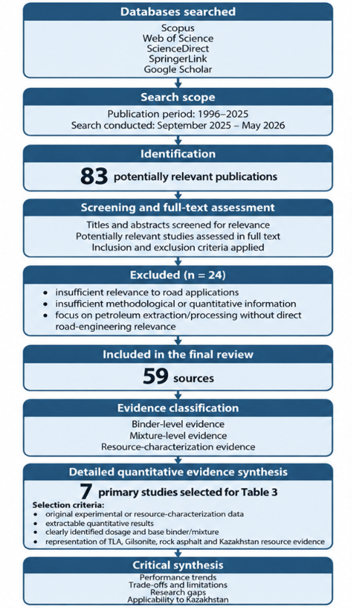

Figure 1 - Literature search, screening and evidence-synthesis workflow used in the structured narrative review.
[Authors’ material]

3 RESULTS AND DISCUSSION

Natural bitumen is a complex natural hydrocarbon material of organic origin, formed as a result of long-term geological processes of oil transformation under the influence of temperature, pressure, oxidation processes, evaporation of light fractions and biochemical degradation [32]. The formation of natural bitumen takes millions of years and is associated with the migration of heavy petroleum components into cracks and the pore space of rocks, where volatile compounds are gradually lost and the proportion of high-molecular weight components, particularly asphaltenes, increases [33].
Natural bitumen generally exhibits higher stiffness and a higher content of heavy polar fractions than conventional petroleum bitumen, although its properties vary considerably depending on origin and composition [34]. Long-term geological interaction with the environment leads to the fact that natural bitumen has an increased content of polar components that improve interactions with mineral materials and increase adhesive performance [35].
From a geological perspective, natural bitumen is formed as a result of complex degradation processes affecting heavy oils. As oil migrates to the near-surface zones, evaporation of light fractions occurs, accompanied by oxidation and polymerization of heavy hydrocarbons, which contributes to an increase in molecular weight and an increase in the concentration of tar-asphaltene compounds [36]. It is these processes that determine the unique properties of natural bitumen, including a high softening temperature, low penetration, and increased resistance to plastic deformation.
Natural bitumens differ in origin, chemical composition, physicomechanical properties, mineral content and degree of natural transformation. In the world practice of road construction, the most common classification of natural bitumen is based on genetic and physico-chemical characteristics, according to which natural asphalts, asphaltites, bituminous rocks and pyrobitums are distinguished [37-38].
For clarity, the terminology used in this review distinguishes several related but compositionally different natural materials. “Natural bitumen” is used as a broad term for naturally occurring heavy hydrocarbon materials formed through geological alteration of petroleum. “Natural asphalt” refers to naturally occurring mixtures of bituminous and, in some cases, mineral components, with Trinidad Lake Asphalt representing a characteristic example. “Asphaltite” refers to solid or semi-solid highly bituminous materials with a high content of heavy organic fractions; Gilsonite is a well-known representative of this group. “Rock asphalt” denotes mineral rock naturally impregnated with bitumen and therefore contains a substantial mineral phase. “Petrobituminous rocks” or oil sands refer to mineral matrices containing extractable natural bituminous organic matter. Because terminology varies among published studies, the original material designation is retained when individual investigations are discussed.
The group of natural asphalts includes highly viscous hydrocarbon materials containing significant amounts of asphaltenes and resinous compounds. They are characterized by an increased softening temperature, low penetration, and high resistance to thermal aging [39]. The most famous representative of this group is Trinidad Lake Asphalt (TLA), a natural asphalt of lake origin mined on the island of Trinidad. This material is characterized by a unique natural structure containing both bitumen and mineral components, which ensures its high resistance to rutting and aging [40]. Table 1 summarizes the effect on the physico-mechanical properties of bitumen grade 35/50 with different TLA content.

Table 1 - Physical properties of TLA-modified binders [3].

№ | Properties | Unit | 35/50 (base) | 35/50+10% TLA | 35/50+20% TLA | 35/50+30% TLA | 35/50+40% TLA | 35/50+50% TLA
1 | 2 | 3 | 4 | 5 | 6 | 7 | 8 | 9
1 | Penetration at 25 °C | [× 0.1 mm] | 42.8±0.8 | 39.9±1.2 | 31.8±1.9 | 25.9±0.4 | 23.3±0.4 | 21.2±0.3
2 | Softening point | [°C] | 55.1±0.6 | 56.9±0.5 | 59.3±0.2 | 60.2±0.6 | 61.2±0.3 | 62.6±0.2
3 | Fraass breaking point (PR) | [°C] | -13.0±1.5 | -12.0±2.4 | -12.0±2.1 | -11.0±0.9 | -10.0±0.9 | -8.0±1.6
4 | Plasticity range (PR) | [°C] | 68.1±1.5 | 68.9±2.5 | 71.3±0.9 | 71.2±0.9 | 71.2±0.9 | 70.6±1.6
5 | Penetration index (IP) | [-] | -0.35±0.13 | -0.14±0.10 | -0.14±0.13 | -0.40±0.11 | -0.39±0.06 | -0.32±0.04

These results demonstrate an important performance trade-off associated with natural bitumen modification. Increasing the TLA content from 0 to 50% reduced penetration from 42.8 to 21.2 × 0.1 mm and increased the softening point from 55.1 to 62.6 °C, indicating a progressive increase in binder stiffness and high-temperature stability. At the same time, the Fraass breaking point shifted from −13 to −8 °C, indicating a potential deterioration in low-temperature flexibility. Kolodziej et al. [3] therefore suggested that a TLA content close to 20% may provide a more appropriate balance for the investigated 35/50 binder, while substantially higher contents may result in excessive stiffening.
This example illustrates why the performance of natural-bitumen-modified materials cannot be assessed solely based on increased stiffness or high-temperature resistance. An improvement in rutting-related properties may be accompanied by reduced low-temperature flexibility, and the optimum modifier content therefore depends on the type of natural bitumen, base binder, climatic conditions and required pavement performance.
Asphaltites include Gilsonite, a solid natural hydrocarbon formed because as a result of the extensive geological transformation of petroleum at high temperatures and pressures [41]. Gilsonite is characterized by a high content of asphaltenes, low temperature susceptibility and high compatibility with petroleum bitumen, which makes it one of the most promising natural modifiers for road construction [41-42].
A separate group consists of rock asphalt (natural asphalt rocks) – rocks impregnated with bituminous substances of natural origin [43]. Depending on the deposit, the bitumen content in rock asphalt can vary widely, reaching 10-35% of the total mass of the material [44]. The peculiarity of these materials is the presence of a mineral phase, which additionally helps to increase the rigidity and structural stability of asphalt concrete mixtures.
Petrobituminous rocks found in various regions of the world, including Kazakhstan, are of considerable interest. Such rocks are a promising source of natural hydrocarbon raw materials and can be used as potential modifiers of road bitumen after appropriate technological processing [45]. Experimental characterization of selected Kazakhstan oil sands provides more specific evidence. Tileuberdi et al. reported an organic fraction of approximately 16% for Munayli-Mola oil sand and about 11–12% for Beke oil sand, depending on the extraction procedure and reported dataset. These values characterize the investigated samples and should not be interpreted as a universal composition range for all Kazakhstan oil-bitumen resources [16].
By chemical composition, natural bitumen mainly consists of saturated hydrocarbons, aromatic compounds, resins and asphaltenes (SARA analysis). However, the ratio of these components varies significantly depending on the origin of the material. For example, gilsonite is characterized by an exceptionally high asphaltene content (up to 70-80%), whereas Trinidad Lake Asphalt contains a significant mineral phase contributing to the structural hardening of the material [46]. The main characteristics of gilsonite, rock asphalt and petrobituminous rocks are comparatively summarized in Figure 1.

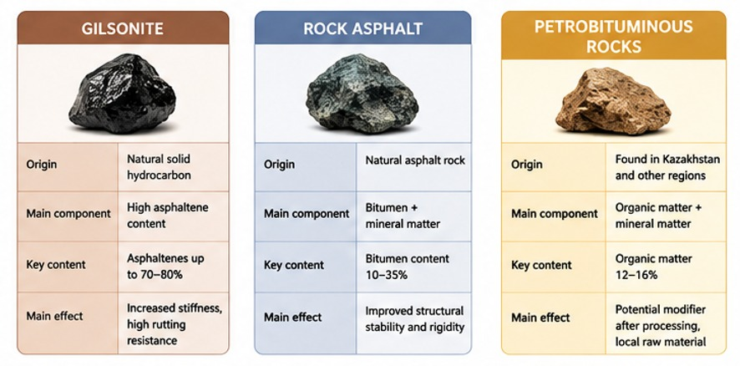

Figure 2 - Comparative characteristics and potential technical effects of basic natural bitumen materials.
[Authors’ material]

The high content of asphaltenes is considered a key advantage of natural bitumen in road construction. Asphaltenes act as structure-forming components that increase the rigidity of bitumen binders, resistance to plastic deformation and rutting [47]. At the same time, an excessive increase in the proportion of asphaltenes can increase the fragility of the material at low temperatures, which requires the search for an optimal balance between stiffness and crack resistance [48].
The main types of natural bitumen used in road construction are listed in Table 2.

Table 2 – General characteristics, potential advantages and limitations of the main natural bitumen types considered in the review.

№ | A type of natural bitumen | Origin | Basic properties | Advantages | Limitations
1 | Gilsonite | Asphaltite | High asphaltene content, high rigidity | Reported improvement in rutting and aging resistance | Possible reduction of low-temperature crack resistance
2 | Trinidad Lake Asphalt (TLA) | Lake natural asphalt | Bitumen + mineral phase | Reported improvements in adhesion-related properties and aging resistance | Increased binder viscosity and reduced workability at high contents
3 | Rock Asphalt | Bitumen-soaked rock | High rigidity, mineral reinforcement | Increasing the modulus of elasticity | Reduced plasticity
4 | Petrobituminous rocks (oil sands) | Natural deposits of heavy hydrocarbons | Potential use of locally available raw materials | Potential for local production and processing | Limited road-performance evidence

It should be noted that the choice of a specific natural bitumen should be carried out considering the climatic conditions of the region, the traffic load, the composition of the asphalt mixture and the requirements for the performance characteristics of the coating. For example, for regions with a hot climate and heavy freight traffic, materials that provide increased resistance to rutting are preferable, whereas for cold regions, ensuring sufficient low-temperature crack resistance remains the most important criterion [49].
The physico-chemical characteristics of natural bitumen determine their behavior in the composition of bitumen binders and have a direct impact on the operational properties of asphalt concrete coatings. Unlike traditional petroleum bitumen, natural bitumen has a significantly higher molecular weight, an increased content of highly polar components, and an altered ratio of structural fractions [50].
The key parameters determining the suitability of natural bitumen for road construction are penetration, softening temperature, viscosity, asphaltene content, density, temperature susceptibility and chemical composition [34].
One of the most characteristic features of natural bitumen is the low penetration value, indicating increased rigidity of the material. Thus, gilsonite is characterized by almost zero penetration at a temperature of 25 °C, which indicates an extremely high stiffness [51]. When incorporated into petroleum bitumen, Gilsonite reduces binder penetration and increases the softening point, indicating increased binder stiffness and improved resistance to deformation at elevated temperatures [46].
An equally important parameter is the softening temperature, reflecting the ability of the bitumen material to maintain structural stability at elevated operating temperatures. For natural bitumen, the softening temperature can exceed 120-200 °C, whereas for traditional petroleum bitumen it is significantly lower [52]. This property is especially important in regions with a hot climate, where road surfaces experience intense thermal effects.
A special role is played by the asphaltene component, which is the main structure-forming component of natural bitumen. The high content of asphaltenes helps to increase the rigidity of the bitumen binder, improve the resistance to rutting and increase resistance to oxidative aging [53]. At the same time, an increase in asphaltene content is accompanied by an increase in viscosity and may lead to a deterioration in the processability of asphalt concrete mixtures.
To provide a more transparent comparison of the experimental evidence reported in the literature, selected primary studies were summarized according to the type and origin of natural bitumen, base binder or asphalt mixture, modifier dosage and principal quantitative findings. Binder-level, mixture-level and resource-characterization studies were distinguished to avoid direct extrapolation of binder properties to asphalt-mixture or pavement performance. The resulting evidence synthesis is presented in Table 3.

Table 3 – Selected quantitative evidence on natural bitumen modification and Kazakhstan oil-sand resource characterization.

№ | Study | Natural bitumen: origin and relevant characteristics | Base binder / asphalt mixture | Modifier dosage | Main quantitative results | Critical interpretation / limitation
1 | 2 | 3 | 4 | 5 | 6 | 7
1 | Kolodziej et al. (2021) [3]  Binder level | Trinidad Lake Asphalt (TLA), Trinidad; hard natural asphalt containing a mineral fraction; penetration ≈4.0 × 0.1 mm, softening point ≈101.2°C | 35/50 paving-grade bitumen | 10, 20, 30, 40 and 50% TLA | At 50% TLA, penetration at 25°C decreased from 42.8 to 21.2 × 0.1 mm, softening point increased from 55.1 to 62.6°C, while Fraass breaking point changed from −13 to −8°C. Authors identified approximately 20% TLA as a more balanced content | Clear stiffness–low-temperature trade-off. Higher TLA contents improve stiffness/high-temperature characteristics but may increase low-temperature cracking susceptibility. Results apply to the investigated 35/50 binder and should not be generalized to all binders

Table 3 (continued)
№ | Study | Natural bitumen: origin and relevant characteristics | Base binder / asphalt mixture |  | Modifier dosage | Main quantitative results | Critical interpretation / limitation
1 | 2 | 3 | 4 |  | 5 | 6 | 7
2 | Slowik and Bilski (2017) [46]  Binder level | Gilsonite, Uinta Basin, Utah, USA; hard asphaltite with very high organic/bituminous content | 35/50 and 50/70 paving bitumens; quantitative example shown for 35/50 |  | Gilsonite: 3, 5 and 7% | For 35/50 binder, penetration at 25°C decreased from 40.8 to 19.8 × 0.1 mm and softening point increased from 55.9 to 65.3°C at 7% Gilsonite. BBR stiffness at −24°C increased from 427 to 590 MPa. Critical temperature changed from −30°C at 3% to −26°C at 7% Gilsonite in unaged condition | Demonstrates increased stiffness and high-temperature stability, but progressive deterioration of low-temperature relaxation characteristics.
3 | Rondón Quintana et al. (2015) [10]  Binder – mixture level | Gilsonite-type natural asphalt from Cesar, Colombia; hard natural asphalt with high asphaltene content | AC 60–70 binder and MDC-19 hot-mix asphalt |  | 5, 10 and 15% Gilsonite relative to asphalt binder mass; wet and dry processes | At 10% wet modification, high-temperature PG increased from PG 58 to PG 70. Wet-modified 10% mixture showed unconditioned ITS 1281.4 kPa, conditioned ITS 1106.7 kPa, and TSR 86.4%. The 10% wet process produced the highest strength/stiffness among the investigated modified mixtures | Improvement was strongest under high-temperature conditions. Low-temperature performance deteriorated and embrittlement was identified as a potential limitation. Wet and dry modification results should not be treated as equivalent
4 | Zuluaga-Astudillo et al. (2021) [51]  Binder – mixture level | Gilsonite; reported penetration 0 × 0.1 mm, softening point 92°C, specific gravity 1.03; geographical source not clearly specified in the study | AC 60–70 binder; dense HMA containing natural aggregate and recycled concrete aggregate (RCA) | 10% Gilsonite by mass of asphalt binder, wet process |  | Binder penetration at 25°C decreased from 63.8 to 42.0 × 0.1 mm, softening point increased from 51.7 to 75.6°C, and viscosity at 135°C increased from 0.35 to 1.02 Pa·s | Mixture results are confounded by simultaneous RCA replacement. Benefits were more appropriate for thick asphalt layers in hot climates, use in thin layers under cold conditions was not recommended. Effects cannot be attributed solely to Gilsonite at mixture level
5 | Li et al. (2019) [9]  Binder – mixture level | North Sichuan rock asphalt (NS RA), China; naturally occurring rock asphalt containing mineral and bituminous phases | Zhonghai AH-70 / Esso AH-70 binders and asphalt mixtures with five gradations | Optimum content ≈ 8% NS RA |  | Dynamic stability of modified mixtures was at least 3 times that of base mixtures; fatigue life was at least 14.5 times higher; freeze–thaw splitting strength ratio increased by at least 9.5%. Structural calculation showed rut depth decreasing from 9.15 to 5.12 mm (≈44%) | Strong mixture-level evidence for rutting and fatigue, but low-temperature performance slightly decreased. Results are specific to NS RA, Chinese materials, gradations and test specifications

Table 3 (continued)
№ | Study | Natural bitumen: origin and relevant characteristics | Base binder / asphalt mixture | Modifier dosage | Main quantitative results | Critical interpretation / limitation
1 | 2 | 3 | 4 | 5 | 6 | 7
6 | Wang et al. (2023) [8]  Mixture level, co-modified system | Qingchuan rock asphalt, China; selected from five rock-asphalt sources because of comparatively high asphalt content and lower ash content | asphalt and high-modulus asphalt mixtures | Selected composition: 6% rock asphalt + 20% rubber powder | Compressive resilience modules at 15°C increased from 1868 to 2599 MPa for 13-mm mixture and from 2229 to 2965 MPa for 20-mm mixture. Dynamic stability increased by approximately 82% and 66%, respectively. Fatigue lives remained broadly comparable: at 500 με, 72,400 vs 74,320 cycles | This is a composite-modification study. Improvements cannot be attributed to rock asphalt alone because rubber powder was intentionally used to compensate for the deterioration in low-temperature performance caused by rock asphalt
7 | Tileuberdi et al. (2015) [16]  Resource characterization | Oil sands from Munayli-Mola (Atyrau Region) and Beke (Mangystau Region), Kazakhstan | Natural oil-sand material; no paving-grade binder or asphalt mixture tested | No modifier dosage; characterization of natural resource | Solvent extraction yielded approximately 16% organic fraction for Munayli-Mola and 11–12% for Beke. Thermal processing yielded 13.5% and 9.6%, respectively | Provides direct evidence of Kazakhstan natural-bitumen resources but does not demonstrate suitability as an asphalt modifier or road-performance improvement. Binder compatibility, optimum dosage and asphalt-mixture performance remain to be established experimentally

The quantitative results summarized in Table 3 should not be interpreted as directly comparable performance rankings. The reviewed studies differ substantially in natural-bitumen origin and composition, base binder grade, modifier dosage and dosage basis, mixture gradation, modification procedure, aging and conditioning protocol, test standard and test temperature. Accordingly, the reported values are used primarily to identify consistent performance trends and trade-offs rather than to establish universal quantitative relationships. Improvements in binder stiffness or rheological parameters do not necessarily imply equivalent improvements in asphalt-mixture or pavement performance.
The Republic of Kazakhstan has significant potential of natural hydrocarbon resources, including oil-bitumen rocks, which are considered as a potential source of natural modifiers for road construction. Published studies document a number of oil-sand and bituminous-rock occurrences in western Kazakhstan, including Munaily-Mola and Beke [16]. However, the terminology and estimates of their number and economically recoverable reserves vary between sources. Among the oil-sand areas reported in the literature are Beke, Munaily-Mola, Kenkiyak [54], their location is shown in Figure 2.
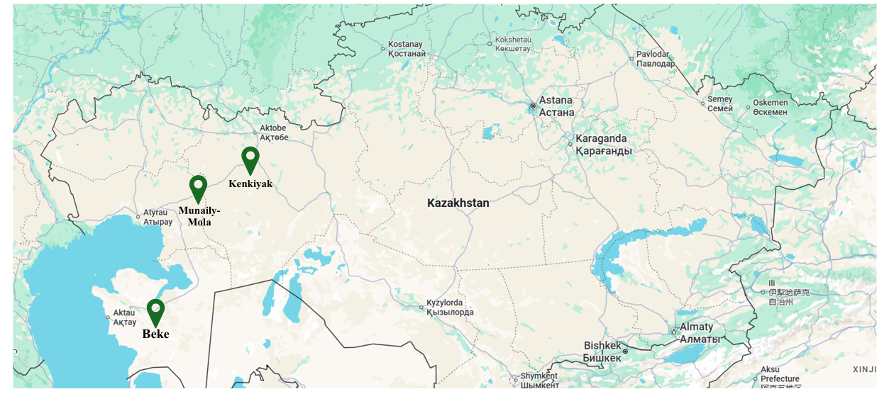
Figure 3 - Location of the Beke, Munaily-Mola, and Kenkiyak deposits
(developed by the authors based on Google Maps). [Authors’ material]

As noted above, the organic fraction reported for the investigated Munayli-Mola and Beke oil sands was approximately 16% and 11-12%, respectively [16]. These values refer to the specific materials investigated and cannot be generalized to all Kazakhstan oil-bitumen resources. Nevertheless, the presence of heavy hydrocarbons, resins and asphaltenes in selected domestic resources indicates their potential relevance for further investigation as road-bitumen modifiers [31].
Several technological approaches have been proposed for processing Kazakhstan oil-bitumen resources, including solvent extraction, thermal upgrading, catalytic cracking and oxidation technologies. These processes make it possible to obtain products that can potentially be used as modifiers of petroleum bitumen. The use of domestic natural raw materials is becoming particularly relevant in the context of an increase in the cost of imported polymer modifiers and the need to increase the technological independence of the road industry in Kazakhstan. The utilization of domestic bituminous resources may contribute to reducing dependence on imported polymer modifiers, increasing technological independence and promoting the development of sustainable road materials based on locally available raw materials [45].
The practical use of natural bitumen also involves several technological and economic constraints. Depending on its origin and physical form, the material may require crushing, drying, extraction, beneficiation or other preliminary processing before incorporation into paving bitumen or asphalt mixtures. Variations in organic and mineral content may complicate material homogenization, dosage control and quality assurance. In addition, the increase in binder viscosity associated with some natural bitumen modifiers can affect mixing and compaction temperatures, workability and energy consumption. Compatibility with the base petroleum bitumen and stability during production and storage should therefore be verified for each material–binder system. From an economic perspective, the availability of domestic resources alone does not guarantee cost effectiveness, because extraction, processing, transportation, energy requirements and quality-control costs must also be considered. Consequently, pilot-scale processing trials and techno-economic assessment are required before large-scale implementation of Kazakhstan natural-bitumen resources can be recommended [16, 17, 42, 52, 54].
Recent studies conducted in Kazakhstan emphasize the importance of resource-saving technologies and the utilization of industrial waste in road construction. Dyusengalieva et al. [55] demonstrated the feasibility of using sulfur-containing by-products from petroleum refining to produce high-quality asphalt concrete, which contributes to waste reduction and promotes sustainable pavement technologies.
Most of the research carried out focuses mainly on the extraction of heavy hydrocarbons and the energy use of raw materials, while the issues of their use in bitumen binders have not been sufficiently studied [56].
Based on the performance mechanisms reported for analogous natural bitumen materials, the following potential effects may be hypothesized for Kazakhstan oil-bitumen rocks:
- potential improvement in laboratory rutting resistance;
- improvement of bitumen adhesion;
- reducing susceptibility to aging;
- increased resistance to moisture degradation.
However, for practical implementation, comprehensive studies are needed, including the determination of optimal dosages, the study of compatibility with domestic petroleum bitumen, the assessment of low-temperature crack resistance and the development of industrial processing technologies. Further investigations are required to evaluate the compatibility of Kazakhstan natural bitumen with conventional petroleum binders, optimize modifier dosage and assess the long-term performance of asphalt mixtures under severe climatic conditions.
Studies conducted in Kazakhstan have also emphasized the importance of sustainable technologies in road engineering. Kosenko et al. [7] demonstrated the feasibility of reusing materials from aged asphalt pavements by restoring binder properties using by-products and waste materials from oil refining and petrochemical industries.
In Kazakhstan, considerable attention is being paid to the development of resource-saving technologies and innovative road materials. Asmatulayev et al. [57] reported that the implementation of patented technologies and materials meeting modern traffic demands contributes to improving the efficiency of road construction while addressing environmental challenges.
Despite extensive investigations devoted to natural bitumen modifiers, several important scientific gaps remain. Most previous studies have focused on individual modifiers such as Gilsonite, Trinidad Lake Asphalt or rock asphalt, whereas comprehensive comparative analyses remain limited.
Furthermore, most experimental studies have been performed in the United States, China and European countries, while investigations considering severe continental climatic conditions are relatively scarce. In addition, the utilization of Kazakhstan oil-bitumen resources for asphalt modification has received limited scientific attention.
Another unresolved issue concerns the optimization of modifier dosage and the balance between rutting resistance and low-temperature crack resistance. Excessive stiffening of the binder may adversely affect pavement performance under cold climatic conditions. Based on the identified scientific gaps, a conceptual research framework is proposed for the practical application of Kazakhstan natural bitumen as a bitumen modifier, as shown in Figure 4.

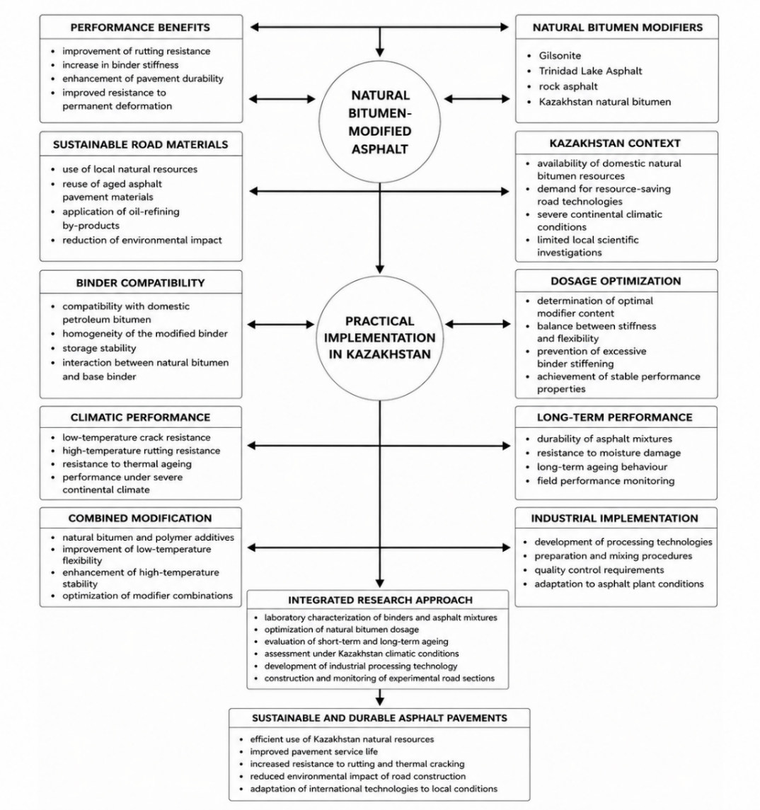

Figure 4 - Proposed research framework for the practical implementation of Kazakhstan natural bitumen as an asphalt binder modifier. [Authors’ material]

As illustrated in Figure 4, future studies should focus on the combined modification of bitumen using natural bitumen and polymer additives, optimization of dosage, evaluation of low-temperature performance and adaptation of international technologies to Kazakhstan conditions.

4 CONCLUSIONS

The reviewed literature indicates that the use of natural bitumen modifiers represents a promising approach to improving selected laboratory-measured properties of asphalt binders and mixtures.
- The reviewed studies report that Gilsonite, TLA and rock asphalt can improve selected binder and mixture properties. The most consistently reported effects include increased binder stiffness and high-temperature stability and, for specific material systems, improved laboratory rutting and moisture-related performance [12-13; 53; 58].
- Among the materials investigated, Trinidad Lake Asphalt has demonstrated improvements in laboratory indicators associated with high-temperature deformation and aging resistance owing to the combined effects of its organic and mineral components. Gilsonite generally exhibits good compatibility with petroleum bitumen and provides a significant increase in binder stiffness and resistance to permanent deformation. Rock asphalt has demonstrated potential in high-modulus asphalt mixtures subjected to heavy traffic loading [3-4; 8; 11; 59].
- At the same time, excessive concentrations of natural bitumen may lead to undesirable effects. An increase in binder viscosity can negatively affect mixture workability and compaction. Excessive stiffening may also reduce low-temperature crack resistance and increase the risk of thermal cracking. Several studies indicate that excessive natural-bitumen contents may increase binder stiffness and viscosity beyond desirable levels, potentially compromising workability and low-temperature cracking resistance. The optimum dosage is therefore material and binder specific [8; 48-49; 53].
- Kazakhstan oil-sand and natural-bitumen resources represent a potential domestic source of road-material modifiers. However, existing Kazakhstan studies mainly address resource characterization and processing, while evidence on compatibility with paving bitumen, asphalt-mixture performance, aging, low-temperature cracking and long-term field behavior remains insufficient. Further experimental and field validation is required before large-scale road application can be recommended.

REFERENCES

- Teltayev, B., Aitbayev, Y., Zhaisanbayev, A. (2024). Problems of rutting on asphalt pavements. Vibroengineering Procedia, 55, 175–180. https://doi.org/10.21595/vp.2024.24088
- Iskakbayev, A., Teltayev, B., Aitbayev, Y., Zhaisanbayev, A. (2024). Accelerated creep of asphalt concrete at medium temperatures. Applied Sciences, 14(20), 9393. https://doi.org/10.3390/app14209393
- Kołodziej, K., Bichajło, L., Siwowski, T. (2021). Experimental study on physical and rheological properties of Trinidad Lake Asphalt modified binder. Applied Sciences, 11(6), 2796. https://doi.org/10.3390/app11062796
- Vigneswaran, S., Yun, J., Lee, M.-S., Lee, S.-J. (2024). Optimizing asphalt binder performance: The synergistic impact of Trinidad Lake Asphalt (TLA) and crumb rubber modifier (CRM). Applied Sciences, 14(15), 6725. https://doi.org/10.3390/app14156725
- Aitkaliyeva G.S., Yelubay M.A., Ismailova A.B., Yerzhanova D.S., Massakbayeva S.R. (2022). Polymeric modifiers for bituminous binders. Bulletin of Kazakh Leading Academy of Architecture and Civil Engineering 1(83), 98-106. https://doi.org/10.51488/1680-080X/2022.1-02
- Kosenko, I. N., Rustemov, I. A., Tursumbekova, H. S., & Umarova, G. B. (2019). Experience in the application of warm asphalt mixtures in road construction [Opyt primeneniya teplykh asfaltovykh smesey v dorozhnom stroitel'stve]. Bulletin of Kazakh Leading Academy of Architecture and Civil Engineering 3(73), 220-225 (in Russ.).
- Kosenko, I. N., Rustemov, I. A., & Tursumbekova, H. S. (2019). Justification for the Reuse of Materials from Old Asphalt Concrete Pavements in the Reconstruction of Highways [Obos novanie povtornogo ispol'zovaniya materialov staryh asfal'tobetonnyh pokrytij pri rekon strukcii avtomobil'nyh dorog]. Bulletin of Kazakh Leading Academy of Architecture and Civil Engineering 3(73), 226-232 (in Russ.).
- Wang, L., Sun, L., Lv, Q. (2023). Design and low-temperature performance evaluation of high-modulus co-modified asphalt mixes with rock asphalt and rubber powder. Applied Sciences, 13(14), 8075. https://doi.org/10.3390/app13148075
- Li, L., He, Z., Liu, W., Hu, C. (2019). A study on the application of rock asphalt from Sichuan China based on anti-rutting performance. Applied Sciences, 9(5), 870. https://doi.org/10.3390/app9050870
- Rondón Quintana, H.A., Hernández Noguera, J.A., Urazán Bonells, C.F. (2015). Behavior of Gilsonite-modified hot mix asphalt by wet and dry processes. Journal of Materials in Civil Engineering, 27(8). https://doi.org/10.1061/(ASCE)MT.1943-5533.0001339
- Ameri, M., Mansourian, A., Ashani, S.S., Yadollahi, G. (2011). Technical study on the Iranian Gilsonite as an additive for modification of asphalt binders used in pavement construction. Construction and Building Materials, 25(3), 1379–1387. https://doi.org/10.1016/j.conbuildmat.2010.09.005
- Ameli, A., Babagoli R., Asadi S., Norouzi N. (2021). Investigation of the performance properties of asphalt binders and mixtures modified by crumb rubber and Gilsonite. Construction and Building Materials, 279, 122424.
https://doi.org/10.1016/j.conbuildmat.2021.122424
- He, Y., Yi, J., Huang, T. (2023). Study on rheological and mechanical properties of rock-compound-additive-modified asphalt and its mixture. Materials, 16(10), 3771. https://doi.org/10.3390/ma16103771
- Ma, J., Cui Y., Xing Y., Chen X., Wu J. (2024). Optimization and pavement performance of Buton rock asphalt modified asphalt mixture with basalt fibre. Case Studies in Construction Materials, 21, e03429. https://doi.org/10.1016/j.cscm.2024.e03429
- Li, Y., Chen J., Yan J., Guo M. (2018). Influence of Buton rock asphalt on the physical and mechanical properties of asphalt binder and asphalt mixture. Advances in Materials Science and Engineering, 2018, 2107512. https://doi.org/10.1155/2018/2107512
- Tileuberdi, Y., Mansurov, Z., Ongarbayev, Y., Tuleutaev, B. (2015). Structural study and upgrading of Kazakhstan oil sands. Eurasian Chemico-Technological Journal, 17, 173–179. https://doi.org/10.18321/ectj208
- Wang, M., Xing, C. (2021). Evaluation of microstructural features of Buton rock asphalt components and rheological properties of pure natural asphalt modified asphalt. Construction and Building Materials, 267, 121132. https://doi.org/10.1016/j.conbuildmat.2020.121132
- Bahia H.U., Hanson D.I., Zeng M., Zhai H., Khatri M.A., Anderson R.M. (2001). Characterization of modified asphalt binders in Superpave mix design. NCHRP Report 459.
- Yildirim, Y. (2007). Polymer modified asphalt binders. Construction and Building Materials, 21(1), 66–72.
- Lu, X., Isacsson, U. (1997). Rheological characterization of styrene-butadiene-styrene copolymer modified bitumen. Construction and Building Materials, 11(1), 23–32.
- Shell. (2003). The Shell Bitumen Handbook. England, United Kingdom.
- Roberts, F.L., Kandhal, P.S., Brown, E.R., Lee, D.Y., Kennedy, T.W. (1996). Hot Mix Asphalt Materials, Mixture Design and Construction. NAPA research and education foundation.
- Huang, Y.H. (2004). Pavement analysis and design (Vol. 2, pp. 401-409). Upper Saddle River, NJ: Pearson/Prentice Hall.
- Asphalt Institute. (2014). MS-2 Asphalt Mix Design Methods.
- Asphalt Institute. (2018). The Asphalt Handbook. 7th ed.
- AASHTO. (2020). AASHTO TP 124. Determining the Fracture Energy of Asphalt Mixtures Using Semi-Circular Bend Geometry.
- European Committee for Standardization. (2012). EN 12697-46. Bituminous mixtures – Test methods for hot mix asphalt – Part 46: Low temperature cracking and properties.
- Ministry of Transport of the People's Republic of China. (2004). JTG F40-2004. Technical Specification for Construction of Highway Asphalt Pavement. Beijing.
- Speight, J.G. (2014). The Chemistry and Technology of Petroleum. CRC Press.
- Tileuberdi, E., Ongarbayev, Y., Behrendt, F., Schneider, I., Imanbayev, Y., Tuleutayev, B., Doszhanov, Y., & Mansurov, Z. (2012). Possibilities of preparation asphalt concrete by oil sands of Kazakhstan. Chemical Bulletin of Kazakh National University, 68(4), 9-13. https://doi.org/10.15328/chemb_2012_49-13
- Sagitova, G.F. et al. (2024). Modified bitumen materials from Kazakhstani oilfield. Advances in Polymer Technology, 2024(1), 8078021. https://doi.org/10.1155/2024/8078021
- Yadykova, A. Y., Strelets, L. A., & Ilyin, S. O. (2023). Infrared Spectral Classification of Natural Bitumens for Their Rheological and Thermophysical Characterization. Molecules, 28(5), 2065. https://doi.org/10.3390/molecules28052065
- Wu, Z., Peng P., Fu J., Sheng G., Liu D. (2000). Bitumen associated with petroleum formation, evolution and alteration—Review and case studies in China. Developments in Petroleum Science, 40, 401–443. https://doi.org/10.1016/S0376-7361(09)70286-9
- Lapidus, A.L., Kerimov V., Mustaev R., Movsumzade E.M. (2018). Natural bitumens: Physicochemical properties and production technologies. Solid Fuel Chemistry, 52(6), 344–355.
https://doi.org/10.3103/S0361521918060071
- Zhai, R., Hao, P. (2021). Research on the impact of mineral type and bitumen ageing process on asphalt-mineral adhesion performance based on molecular dynamics simulation method. Road Materials and Pavement Design, 22(9), 2000–2013. https://doi.org/10.1080/14680629.2020.1739119
- Adams, J.J. (2008). The Impact of Geological and Microbiological Processes on Oil Composition and Fluid Property Variations in Heavy Oil and Bitumen Reservoirs. University of Calgary, Department of Geoscience.
- Lyapin, A.A., Parinov I.A., Buravchuk N.I., Cherpakov A.V., Shilyaeva O.V., Guryanova O.V. (2021). Improving Road Pavement Characteristics: Applications of Industrial Waste and Finite Element Modelling. Springer, Cham. https://doi.org/10.1007/978-3-030-59230-1
- Baghsangani, S.H.H. (2018). Composition, Properties, Origin and Evolutionary Pathways of Solid Bitumens from SE Turkey: Improved Process Understanding Through Advanced Geochemical Characterization. Technische Universität Berlin.
- Nciri, N., Kim J., Kim N., Cho N. (2016). An in-depth investigation into the physicochemical, thermal, microstructural and rheological properties of petroleum and natural asphalts. Materials, 9(10), 859. https://doi.org/10.3390/ma9100859
- Charles, R., Grimaldi, F. (1996). Trinidad Lake Asphalt in pavement performance. West Indian Journal of Engineering.
- Nciri, N., Song, S., Kim, N., & Cho, N. (2014). Chemical characterization of gilsonite bitumen. Journal of Petroleum & Environmental Biotechnology, 5(5), 1. http://dx.doi.org/10.4172/2157-7463.1000193
- Al Hawesah, H., Sadique, M., Harris, C., Al Nageim, H., Stopp, K., Pearl, H., & Shubbar, A. (2021). A review on improving asphalt pavement service life using gilsonite-modified bitumen. Sustainability, 13(12), 6634. https://doi.org/10.3390/su13126634
- Ma, F., Wang, Y., Fu, Z., Tang, Y., Dai, J., Li, C., & Dong, W. (2022). Thermal ageing mechanism of a natural rock-modified asphalt binder using Fourier Transform Infrared Spectroscopy analysis. Construction and Building Materials, 335, 127494. https://doi.org/10.1016/j.conbuildmat.2022.127494
- Rahman, M.T., Mohajerani, A., Giustozzi, F. (2020). Recycling of waste materials for asphalt concrete and bitumen: A review. Materials, 13(7), 1495. https://doi.org/10.3390/ma13071495
- Shambilova, G. K., Iskakov, R. M., Shazhdekeyeva, N. K., Kuanbayeva, B. U., Kuzin, M. S., Skvortsov, I. Y., & Makarov, I. S. (2025). Environmentally sustainable and climate-adapted bitumen-composite materials for road construction in Central Asia. Infrastructures, 10(12), 345. https://doi.org/10.3390/infrastructures10120345
- Słowik, M., Bilski, M. (2017). An experimental study of the impact of aging on Gilsonite and Trinidad Epuré modified asphalt binders properties. The Baltic Journal of Road and Bridge Engineering, 12(2), 71–81. https://doi.org/10.3846/bjrbe.2017.09
- Pipintakos, G., Sreeram, A., Mirwald, J., & Bhasin, A. (2024). Engineering bitumen for future asphalt pavements: A review of chemistry, structure and rheology. Materials & Design, 244, 113157. https://doi.org/10.1016/j.matdes.2024.113157
- Hamedi, G.H., Asadi, A.H., Zarrinfam, J. (2024). Investigating the effect of fundamental properties of materials on the mechanisms of thermal cracking of asphalt mixtures. Construction and Building Materials, 411, 134426. https://doi.org/10.1016/j.conbuildmat.2023.134426
- Ma, R., Li, Y., Cheng, P., Chen, X., & Cheng, A. (2024). Low-temperature cracking and improvement methods for asphalt pavement in cold regions: A review. Buildings, 14(12), 3802. https://doi.org/10.3390/buildings14123802
- Redelius, P.G. (2006). The structure of asphaltenes in bitumen. Road Materials and Pavement Design, 7(Suppl. 1), 143–162. https://doi.org/10.1080/14680629.2006.9690062
- Zuluaga-Astudillo, D.A., Rondón-Quintana, H.A., Zafra-Mejía, C.A. (2021) Mechanical Performance of Gilsonite Modified Asphalt Mixture Containing Recycled Concrete Aggregate. Appl. Sci. 11, 4409. https://doi.org/10.3390/app11104409
- Mohsin, H.K., Latief, R.H. (2025). Natural bitumen in hot asphalt mixture: Suitability of using treated natural bitumen instead of petroleum asphalt binder. IIUM Engineering Journal, 26(2), 27–50. https://doi.org/10.31436/iiumej.v26i2.3452
- Abraham, S.M., Verma, M., Kakade, V. (2023). Aging resistance of bitumen modifiers: A comprehensive review. Journal of Testing and Evaluation, 51(5), 3533–3560. https://doi.org/10.1520/JTE20220456
- Ongarbayev, Y., Golovko, A., Krivtsov, E., Tileuberdi, E., Imanbayev, Y., Tuleutayev, B., & Mansurov, Z. (2014). Thermocatalytic cracking of Kazakhstan’s natural bitumen. Studia UBB Chemia, 59(4), 57–64. https://www.researchgate.net/profile/Evgenii-Krivtsov/publication/277282058_Thermocatalytic_cracking_of_Kazakhstan's_natural_bitumen/links/5565b3b208ae94e957208996/Thermocatalytic-cracking-of-Kazakhstans-natural-bitumen.pdf
- Dyusengalieva T.M., Seitkazinov O.D., Aidarbaeva D.R. (2019). Application of new technologies in the construction of roads in Kazakhstan. Bulletin of Kazakh Leading Academy of Architecture and Civil Engineering 3(73), 185-190 https://vestnik.kazgasa.kz//frontend/web/uploads/archive/doc/1608188343_hIPxbt.pdf
- Shah, A., Fishwick, R., Wood, J., Leeke, G., Rigby, S., & Greaves, M. (2010). A review of novel techniques for heavy oil and bitumen extraction and upgrading. Energy and Environmental Science, 3(6), 700–714. https://doi.org/10.1039/b918960b
- Asmatulayev B.A., Asmatulayev R.B., Ezmakhunov R.R. (2018). Resource-saving technologies for road construction in Kazakhstan [Resursosberegayushchie tekhnologii stroitel'stva avtomobil'nykh dorog Kazakhstana]. Bulletin of Kazakh Leading Academy of Architecture and Civil Engineering 4(70), 113-120 (in Russ.) https://vestnik.kazgasa.kz//frontend/web/uploads/archive/doc/1608146737_dlEo9h.pdf
- Kołodziej, K., Bichajło, L., Siwowski, T. (2021). Effects of aging on the physical and rheological properties of Trinidad Lake Asphalt modified bitumen. Materials, 14(10), 2532. https://doi.org/10.3390/ma14102532
- Alia, A.M., Naser, A.F., Jawad, Z.F. (2025). A review of the use of natural asphalt in hot mix asphalt for flexible pavement construction. Jurnal Kejuruteraan, 37(7), 3173–3195. https://doi.org/10.17576/jkukm-2025-37(7)-07

FUNDING

The study was conducted using private sources of funding.

CONFLICT OF INTEREST

The authors state that there is no conflict of interest.

ARTIFICIAL INTELLIGENCE STATEMENT

During the preparation of this manuscript, the authors used artificial intelligence tools solely for editorial assistance, such as improving phrasing and checking grammar, spelling, and punctuation. All ideas, interpretations, and conclusions are the responsibility of the authors, who take full accountability for the content of the article.
AUTHOR CONTRIBUTIONS
M. B. Zhumamuratov – conceptualization, methodology, literature search, data curation, formal analysis, visualization, writing-original draft.
N. E. Bekturganova – conceptualization, supervision, methodology, validation, writing-review and editing.
D.E. Yessentay – supervision, methodology, interpretation of results.
J. Valentin – scientific supervision, validation, writing – review and editing.
I.S. Bondar – supervision, validation, writing – review and editing.

INFORMATION ABOUT THE AUTHORS

- M.B. Zhumamuratov
- PhD Student,
- KazADI named after L.B. Goncharov
- Almaty, Kazakhstan
- E-mail address: zhumamuratovmanarbek@gmail.com
- ORCID ID: https://orcid.org/0000-0003-3516-9271

- N. E. Bekturganova
- Candidate of Chemical Science, Associate Professor
- KazADI named after L.B. Goncharov
- Almaty, Kazakhstan
- E-mail address: bektur_n@mail.ru,
- ORCID ID: https://orcid.org/0000-0003-3062-3340

- D.E. Yessentay
- PhD, Associate Professor,
- KazADI named after L.B. Goncharov
- Almaty, Kazakhstan
- E-mail address: yessentaydauren@gmail.com
- ORCID ID: https://orcid.org/0000-0002-8443-1398

- J. Valentin
- PhD, Associate Professor
- Czech Technical University in Prague
- Prague, Czech Republic
- E-mail address: jan.valentin@fsv.cvut.cz,
- ORCID ID: https://orcid.org/0000-0001-9155-1921

- I.S. Bondar
- Candidate of Technical Science, PhD, Associate Professor
- KazADI named after L.B. Goncharov
- Almaty, Kazakhstan,
- E-mail address: ivan_sergeevich_08@mail.ru
- ORCID ID: https://orcid.org/0000-0001-7376-5643

Received: 22 July 2026
Revised: 3 August 2026
Accepted: 16 September 2026

